## REF VS USEREF REACT JS

The **ref** is used to return a reference to the element. **Refs** should be avoided in most cases, however, they can be useful when we need DOM measurements or to add methods to the components

CLASS COMPONENT

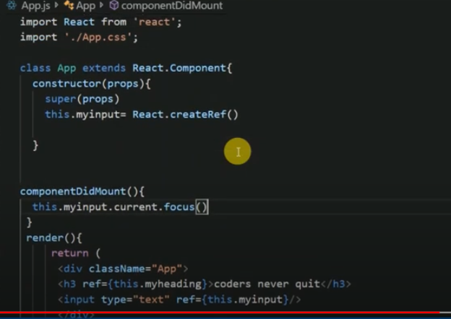

FUNCTIONAL COMPONENT

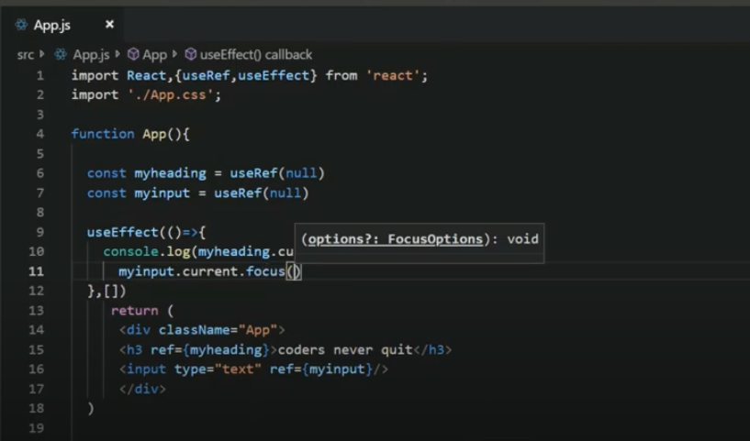

OUTPUT

